AI-Based Early Disease Risk Prediction System Using Machine Learning

A Project Report
Submitted by:
Priyansu Nayak (2241014108)
Subhojeet Sarkar (2241019321)
Himanshu Sekhar Dash (2241004163)
Pikesh Yadav (2241025009)

in partial fulfillment for the award of the degree
of
BACHELOR OF TECHNOLOGY
IN
COMPUTER SCIENCE AND ENGINEERING


DEPARTMENT OF COMPUTER SCIENCE AND ENGINEERING
Faculty of Engineering and Technology, Institute of Technical Education and Research
SIKSHA ‘O’ ANUSANDHAN (DEEMED TO BE) UNIVERSITY
Bhubaneswar, Odisha, India
(June 2026)


CERTIFICATE

This is to certify that the project report titled “AI-Based Early Disease Risk Prediction System Using Machine Learning ” being submitted by Priyansu Nayak, Subhojeet Sarkar, Himanshu Sekhar Dash and Pikesh Yadav of Section-2241026 to the Institute of Technical Education and Research, Siksha ‘O’ Anusandhan (Deemed to be) University, Bhubaneswar for the partial fulfillment for the degree of Bachelor of Technology in Computer Science and Engineering is a record of original confide work carried out by them under my/our supervision and guidance. The project work, in my/our opinion, has reached the requisite standard fulfilling the requirements for the degree of Bachelor of Technology.
The results contained in this project work have not been submitted in part or full to any other University or Institute for the award of any degree or diploma.


Dr. Bhanu Pratap Rajak

Department of Computer Science and Engineering
Faculty of Engineering and Technology;
Institute of Technical Education and Research;
Siksha ‘O’ Anusandhan (Deemed to be) University

ACKNOWLEDGEMENT

We would like to express our sincere gratitude to our project supervisor, Dr. Bhanu Pratap Rajak, for his continuous guidance, support, and valuable suggestions throughout the development of this project titled “AI-Based Early Disease Risk Prediction System Using Machine Learning.” His motivation, encouragement, and timely feedback helped us understand various concepts related to machine learning, data analysis, and project implementation. His guidance played an important role in the successful completion of this work.

We are also thankful to the Department of Computer Science and Engineering, Faculty of Engineering and Technology, Institute of Technical Education and Research (ITER), Siksha ‘O’ Anusandhan (Deemed to be University), for providing the necessary facilities, learning resources, and academic environment required for carrying out this project successfully.

 | Signature of Students
 | 
 | 
Place: | 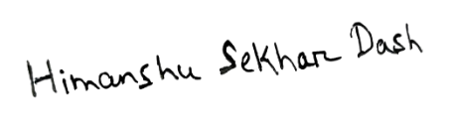
Date: | 

DECLARATION

We declare that this written submission represents our ideas in our own words and where other’s ideas or words have been included, we have adequately cited and referenced the original sources. We also declare that we have adhered to all principles of academic honesty and integrity and have not misrepresented or fabricated or falsified any idea/fact/source in our submission. We understand that any violation of the above will cause for disciplinary action by the University and can also evoke penal action from the sources which have not been properly cited or from whom proper permission has not been taken when needed.

Signature of Students with Registration Numbers

- 2241014108

- 2241019321

- 2241004163

- 2241025009

Date: ————–

REPORT APPROVAL

This project report titled “AI-Based Early Diseases Risk Prediction System Using Machine Learning “submitted by Priyansu Nayak, Subhojeet Sarkar, Himanshu Sekhar Dash and Pikesh Yadav is approved for the degree of Bachelor of Technology in Computer Science and Engineering.

Examiner(s)

________________________
________________________
________________________

Supervisor

________________________

Project Coordinator

________________________

PREFACE
Long-term disease such as diabetes and cardiovascular disease are becoming increasingly common and often remain undetected during their early stages. A delayed diagnosis might result in major health problems, increased health risk and higher expenditures for therapy and long-term medical care. Early forecasting of disease risk can enable people to get medical treatment at the right time, follow healthier lifestyles and take preventive actions.

Using patient health and lifestyle data, this study shows an AI-Based Early Disease Risk Prediction System Using Machine Learning created to estimate the risk of cardiovascular disease and diabetes. For disease prediction, the system makes use of machine learning techniques including Random Forest, Logistic Regression, Support Vector Machine (SVM), and XGBoost. To boost model performance and forecast confidence, data preprocessing, feature selection, SMOTE-based class balancing, hyperparameter optimization, cross-validation, and threshold tuning were among the several methods used.

A Streamlit-based web application was developed to provide real-time disease risk prediction via a clean and user-friendly interface using the trained models. The initiative showcases how machine learning can be applied in medicine to improve early disease identification and promote preventive healthcare system.

INDIVIDUAL CONTRIBUTIONS

Priyansu Nayak | Machine Learning & System Development Lead: Developed and optimized the disease prediction pipeline, implemented preprocessing, feature selection, hyperparameter tuning, and integrated multiple machine learning models for diabetes and cardiovascular disease prediction.
Subhojeet Sarkar | Data Engineering & Validation: Responsible for preparing datasets, dealing with missing data, class imbalance, exploratory data analysis, and validating model performance based on accuracy, precision, recall, and F1 Score.
Himanshu Sekhar Dash | Researcher/Documentation: Performed literature review, studied previous disease prediction techniques, prepared method documentation, and helped in comparison and analysis of results.
Pikesh Yadav | Streamlit UI & Testing: Help in Streamlit based UI Integration, Result Visualization, Prediction Output Testing, Disease Prediction Workflow testing.

TABLE OF CONTENTS
 | Title page | i
 | Certificate | ii
 | Acknowledgement | iii
 | Declaration | iv
 | Report Approval | v
 | Preface | vi
 | Individual Contribution | vii
 | Table of Contents | viii
 | List of Figures | x
 | List of Tables | xi
1. | INTRODUCTION | 1
 | - Project Overview  - Motivation  - Uniqueness of the Work  - Report Layout | 1  1  2  2
2. | LITERATURE SURVEY | 4
 | 2.1 Review of Existing Systems / Related Work  2.2 Research Gaps Identified  2.3 Problem Identification | 4  5  6
3. | MATERIALS AND METHODS | 7
 | 3.1 Dataset(s) Description  3.2 Schematic Layout/Model Diagram  3.3 Methodologies Adopted  3.4 Tools Used  3.5 Experimental Setup  3.6 Evaluation Metrics and Performance Measures | 7  9  10  14  15  16
4. | RESULTS | 18
 | 4.1 System Specification  4.2 Parameters and Configuration Settings  4.3 Experimental Results and Observations  4.4 Performance Analysis and Latency Bottlenecks  4.5 Comparative Study and Discussion | 18  18  19  25  26
5. | CONCLUSIONS | 28
 | 5.1 Summary  5.2 Operational Limitations  5.3 Future Scope | 28  28  29
6. | REFERENCES | 30
7. | APPENDICES | 31
 | Appendix 1: Feature Descriptions and Input Parameters  Appendix 2: Application Implementation and Prediction workflow | 31  37
8. | REFLECTION OF THE TEAM MEMBERS ON THE PROJECT | 42
 | Team Learning  Individual Learning | 42  42
9. | SIMILARITY REPORT | 44

LIST OF FIGURES

NO | FIGURE NAME | PAGE NO
1 | Proposed System Architecture / Model diagram | 9
2 | Complete methodology Workflow | 10
3 | Diabetes Model Comparison Graph | 21
4 | Diabetes Confusion Matrix | 22
5 | Cardiovascular Model Comparison Graph | 24
6 | Cardiovascular Confusion matrix | 25
7 | Diabetes class Distribution | 33
8 | Cardiovascular class Distribution | 36
9  10  11  12  13 | Home Page of the AI-Based Early Disease Risk Prediction System  Diabetes Prediction Interface Showing Low Risk Prediction  Diabetes Prediction Interface Showing High Risk Prediction  Cardiovascular Disease Prediction Interface Showing Low Risk Prediction  Cardiovascular Disease Prediction Interface Showing High Risk Prediction | 39  39  40  40  41

LIST OF TABLES

NO | TABLE NAME | PAGE NO
1 | Diabetes Dataset Sample Tables | 7
2 | Heart Disease Dataset Sample Tables | 8
3 | System specification | 18
4 | Model Configuration Parameters | 19
5 | Diabetes Baseline Model Comparison on Validation Dataset | 20
6 | Diabetes K-Fold Cross-Validation F1 Scores | 20
7 | Diabetes Optimized Model Comparison (Validation) | 20
8  9  10  11  12  13  14  15  16  17 | Diabetes Threshold Tuning  Cardiovascular Baseline Model Comparison on Validation Dataset  Cardiovascular K-Fold Cross-Validation F1 Scores  Cardiovascular Optimized Model Comparison (Validation)  Best Cardiovascular Model  Cardiovascular Threshold Tuning  Final Test Performance Comparison (Diabetes vs. Cardiovascular disease)  Diabetes Disease Dataset Overview  Diabetes Prediction Feature Dictionary  Cardiovascular Disease Dataset Overview  Cardiovascular Disease Prediction Features | 21  22  23  23  24  26  31  31  34  34

CHAPTER 1: INTRODUCTION

  - Project Overview:
The AI-Based Early Disease Risk Prediction System Using Machine Learning is a predictive system that aims to identify the early risk of chronic diseases. This system employs a machine learning algorithm to predict the possibility of developing conditions like diabetes and cardiovascular disease. Also, this system classifies patients into two groups, either group at high-risk or group at low-risk, depending on the health information and lifestyles of patients.

This project covers the entire process of the machine learning pipeline. Various machine learning algorithms were employed and evaluated to select the best one to be used in predicting the probability of the patient having any kind of chronic disease. Techniques like SMOTE were applied in dealing with class imbalance, and feature selection was carried out to extract informative features related to the health of patients. All the machine learning models trained were stored using joblib. Also, a web interface using streamlit library was created.

  - Motivations:
The motivation behind this project comes from the growing segment of the population is affected by long-term health conditions such as diabetes and cardiovascular disease. In many cases, these diseases are detected very late because their symptoms develop slowly and are often ignored in the early stages. Late diagnosis can lead to serious health problems, expensive treatments, and increased risk to human life. This created the need for a simple and smart system that can help people identify possible health risks at an early stage before the condition becomes more serious.

This project employs machine learning methods to study medical data and identify patterns related to disease risk. The system analyzes important health factors such as glucose level measurement, blood pressure reading, age, BMI, and other medical data to predict the possibility of disease with better accuracy. The main goal is to provide an easy-to-use healthcare application that supports early awareness and preventive care. The system can help users make better health decisions, reduce the delay in medical analysis, and support healthier lifestyle managements through AI- based disease prediction.

  - Uniqueness of the work:
The uniqueness of this project is based on the capacity to combine multiple scientific machine learning techniques into a single intelligent healthcare prediction system. Most of the healthcare applications made till date only predict either one disease but this system predicts early risk of diabetes and cardiovascular disease on the same platform. For each disease, separate machine learning pipelines have been developed and used. It is done to perform predictions more effectively.

Another major factor in the project involves using advanced techniques for processing data and improving a model. Feature selection is introduced to single out the most useful medical attributes in order to reduce model complexity while improving prediction accuracy. The project uses SMOTE to treat imbalance datasets. This ensures that minority class samples are properly represented during training. Furthermore, a range of machine learning models is used in order to select the best one.

A simple Streamlit based web application provides predictions of disease risks in real time that enhance the system. The platform features an easy-to-use interface that assists both technical and non-technical users make use of the platform easily and this increases accessibility and practical usability in healthcare support systems.

  - Report layout:
The report is organized into several chapters to clearly and systematically describe the whole development process of the AI-Based Early Disease Risk Prediction System Using Machine Learning.

- Chapter 2: This chapter explains the literature survey related to disease prediction systems. It discusses existing research works, machine learning approaches used by researchers, identified research gaps, and the major problems found in current healthcare prediction systems that motivated the proposed project development.

- Chapter 3: This chapter describes the datasets used, preprocessing methods, machine learning models and development tools used in the project. It also describes the complete methodology that includes feature selection, handling imbalance using SMOTE, threshold tuning, model training, evaluation techniques and deployment process based on Streamlit.

- Chapter 4: In chapter four, the experimental process followed is outlined together with the results obtained through evaluation of the models. A comparison is made among several prediction algorithms based on various classifiers, with the best method being identified for disease risk prediction.

- Chapter 5: The findings of the study, along with their contribution to disease predictions, are discussed in Chapter 5. Apart from that, it identifies some of the constraints faced by the system at present and provides some suggestions for its further development.

- Chapter 6: This chapter contains all the references used during the development of the project report. It mainly includes references of research papers and journals.

- Chapter 7, 8, 9: These chapters include the appendices, team reflections, and similarity report related to the project. They contain additional project information, learning experiences gained during development, supporting materials and plagiarism analysis required for the final project documentation.

CHAPTER 2: LITERATURE SURVEY

- Review of Existing Systems:
The use of machine learning for predicting and handling the cases of chronic diseases has evolved much over the last couple of years. People across the world have tried to develop such intelligent systems that can detect the likelihood of chronic disease before any symptom appears. They aim at helping early detection of such risks in order to treat them on time and avoid further complications.
One of the earliest attempts made towards such a process is seen from the work done by Almustafa (2020)[1]. It involves the study of multiple classifiers used in heart disease prediction. From this work, one could learn that the proper selection of features and classifier can help build up a robust system to predict any disease effectively.

When predicting the onset of diabetes, Deberneh and Kim (2021)[2] introduced a machine learning pipeline involving the use of feature selection methods based on statistics such as ANOVA, Chi-Square testing, and Recursive Feature Elimination, with the purpose of finding the best clinical attributes. This showed that besides increasing accuracy and the correctness of machine learning models, proper feature selection is critical in reducing training costs. Expanding further, Rajendra and Latifi (2021)[3] used both logistic regression and ensemble-based algorithms to predict diabetes. The authors concluded that a combination of weak learners using ensemble learning provides better performance than each individual classifier.

Regarding chronic kidney disease, Poonia et al. (2022)[4] noted that combining feature selection techniques with classification algorithms produces more reliable predictions. They reiterated that raw data alone does not matter since the quality of prediction models relies on how well data is preprocessed and features selected. In another study on heart diseases, Ahmad et al. (2022)[5] combined numerical and categorical features into one machine learning algorithm for prediction purposes.

Simultaneously, Hassan et al. (2022)[6] compared different classifiers for coronary heart disease predictions and noted promising results in multiple algorithms, thus further affirming the usefulness of using data-driven approaches in the diagnostics of cardiac conditions. Islam et al. (2022)[7] explored the possibilities of using machine learning models in the detection of renal disorders to support physicians' work. The results showed the potential of applying the discussed approaches in different areas of medicine. Later on, research was directed towards improving the generalizability of such models. Thus, Uddin et al. (2023)[8] developed a predictive model for cardiovascular diseases based on integrating datasets and combining multiple machine learning algorithms. At the same time, other researchers have started exploring the utilization of machine learning tools to assist practitioners at the point of care. For example, Nguyen et al. (2023)[9] assessed the feasibility of using machine learning techniques to create decision-making tools for physicians working with diabetic patients.

As recently as Alzboon et al. (2025)[10], there has been a comparative analysis of various machine learning methods used in the prediction of diabetes. In particular, their research was able to prove once again that the developments of algorithms positively influence the performance of predictions, while selecting an appropriate model still is an important issue to consider. As can be seen from these and other similar studies, machine learning plays an increasingly important role in predicting chronic diseases; a balanced approach yields the best outcomes.

- Research Gaps Identified:
Although existing systems achieved good prediction accuracy but still several limitations still exist such as:
- Most existing systems focus only on a single chronic disease like either diabetes or cardiovascular / heart disease instead of a multi disease prediction system.
- Although several studies compare multiple machine learning algorithms, many do not integrate feature selection, class imbalance handling, hyperparameter optimization, and threshold tuning within a single prediction framework.
- Existing prediction systems often use default prediction thresholds i.e. 0.5, this reduces the reliability in imbalance healthcare datasets.
- Some systems failed to properly handle class imbalance leading result to biased prediction performance.
- Many existing studies focus primarily on model development and evaluation, with limited emphasis on user-friendly deployment for real-time prediction.
The above limitations motivate the development of a comprehensive chronic diseases prediction system that integrates feature selection, use of SMOTE, hyper-parameter optimization using Optuna, cross-validation, optimal threshold determination, and web application deployment.

- Problem Identification:
Early diagnosis of chronic disease such as diabetes and cardiovascular disease is a key problem, with late diagnosis leading to severe complications and high healthcare expenditures. Traditional medical testing is often expensive, time consuming and not easily available to everyone. Existing AI-based healthcare systems also have several limitations. As highlighted in recent literature, many machine learning models produce less reliable predictions because healthcare datasets are often imbalanced and not handled properly. Furthermore, many models use only single machine learning algorithms instead of comparing multiple models to select the best one. Most research academic models remain limited to academic studies and are not transformed into accessible healthcare applications. The shortcomings identified in the previous studies were to be overcome through the development of a smart framework that can aid in early prediction of long-term disease risk. This study proposes a novel approach that involves the use of machine learning with data pre-processing, class balancing, and the implementation of a user-friendly website through Streamlit.

CHAPTER 3: MATERIALS AND METHODS

- Datasets Description:
For this project we used two healthcare datasets for predicting the early risk of diabetes and cardiovascular disease through machine learning techniques.

Diabetes Dataset: The dataset comprises 6000 patient samples consisting of 19 features related to medical and lifestyle information. The machine learning methods have been employed to examine the risk factors that can diagnose a person’s likelihood of early diabetes. These factors include age, B.M.I, waist circumference, physical activity, stress level, gender, hours of sleep, family history, blood pressure, cholesterol, fasting glucose, HbA1c, triglycerides and insulin levels.

Table 1: Diabetes Dataset Sample Tables
Patient_ID | age | gender | bmi | blood_pressure | fasting_glucose  _level | insulin_level
1 | 77 | Female | 33.8 | 154 | 93 | 12.1
2 | 54 | Male | 19.2 | 123 | 94 | 4.6
3 | 25 | Male | 33.7 | 141 | 150 | 10.8
4 | 23 | Female | 32.8 | 140 | 145 | 11.6
5 | 70 | Male | 33.7 | 165 | 90 | 18.3

HbA1c_level | cholesterol_level | triglycerides_level | physical_activity_level | daily_calorie_intake | sugar_intake_grams_per_day
5.2 | 242 | 194 | Low | 2169 | 78.4
5.4 | 212 | 76 | High | 1881 | 16.5
6.9 | 247 | 221 | Low | 2811 | 147.9
6.8 | 195 | 193 | Low | 2826 | 98.3
5.6 | 217 | 170 | Moderate | 2610 | 65.8

sleep_hours | stress_level | family_history_diabetes | waist_circumference_cm | diabetes_risk_score | diabetes_risk_category
8.1 | 4 | No | 101.1 | 52.3 | Low Risk
6.6 | 3 | No | 60.0 | 3.7 | Low Risk
6.7 | 10 | Yes | 114.7 | 87.3 | High Risk
4.4 | 9 | Yes | 96.6 | 76.1 | High Risk
9.1 | 5 | Yes | 107.4 | 47.7 | Low Risk

Cardiovascular dataset: The dataset consists of 5500 patient data with 17 heart health, daily lifestyle features. We employed machine learning to determine risk factors that can diagnose a person’s likelihood of early cardiovascular disease. These factors include age, BMI, systolic and diastolic blood pressure, cholesterol level, resting heart rate, smoking status, alcohol consumption, sleep duration, physical activity, family history of heart disease.

Table 2: Heart Disease Dataset Sample Tables
Patient_ID | age | bmi | systolic_bp | diastolic_bp | cholesterol_mg_dl
1 | 62 | 25.0 | 142 | 93 | 247
2 | 54 | 29.7 | 158 | 101 | 254
3 | 46 | 36.2 | 170 | 113 | 276
4 | 48 | 30.4 | 153 | 98 | 230
5 | 46 | 25.3 | 139 | 87 | 206

resting_heart_rate | smoking_status | daily_steps | stress_level | physical_activity_hours_per_week | sleep_hours
72 | Never | 11565 | 3 | 5.6 | 8.2
74 | Current | 4036 | 8 | 0.5 | 6.7
80 | Current | 3043 | 9 | 0.4 | 4.0
73 | Former | 5604 | 5 | 0.6 | 8.0
69 | Current | 7464 | 1 | 2.0 | 6.1

family_history_heart_disease | diet_quality_score | alcohol_units_per_week | heart_disease_risk_score | risk_category
No | 7 | 0.7 | 28.1 | Low
No | 5 | 4.5 | 63.0 | High
No | 1 | 20.8 | 73.1 | High
No | 4 | 8.5 | 39.5 | Low
No | 5 | 3.6 | 29.3 | Low

Before model training, the datasets were pre-processed, cleaned, balanced, and transformed to improve prediction accuracy, reduce inconsistencies, and increase the reliability of the overall disease prediction system.

- Schematic Layout/Model Diagram:

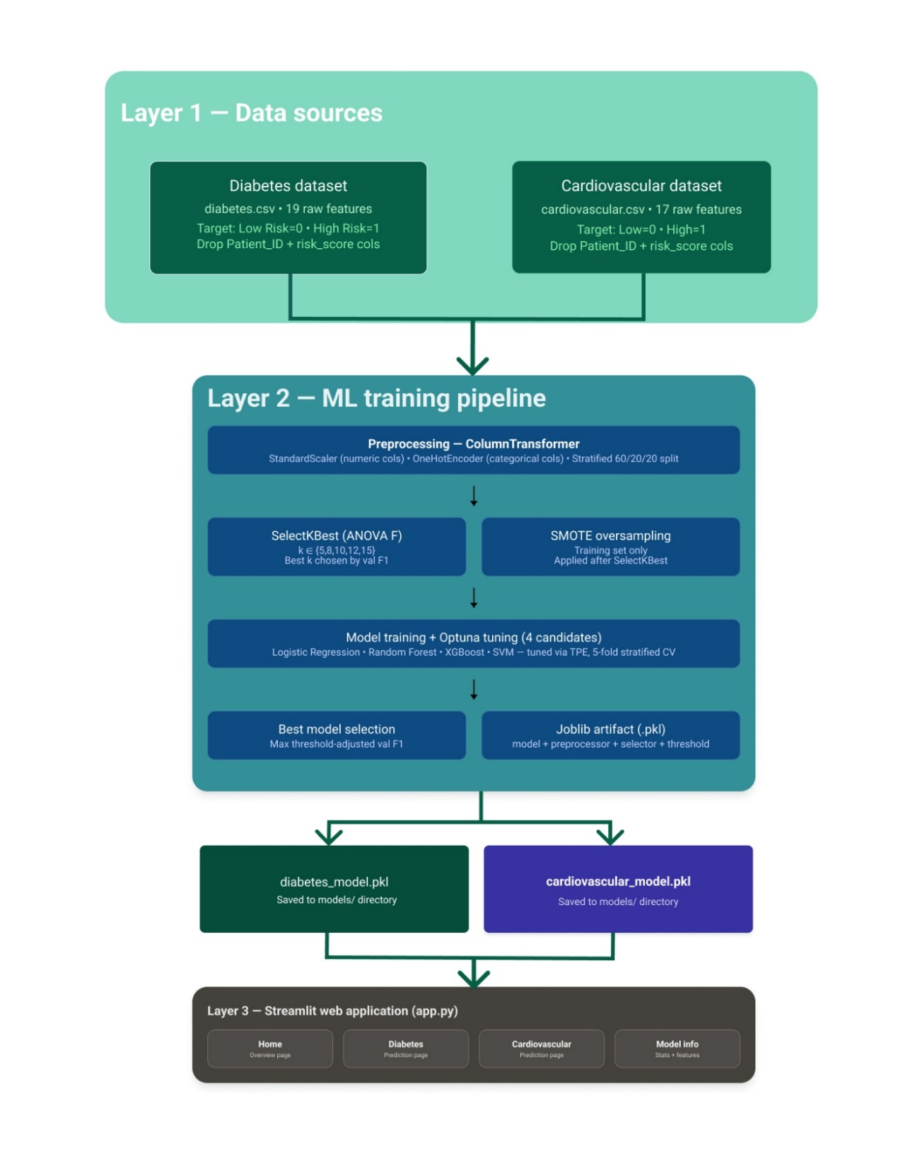

Fig 1: Proposed System Architecture / Model diagram
The system works with two separate machine learning pipelines for early risk prediction. One pipeline handles diabetes and the other focuses on cardiovascular disease. They follow similar steps like data preprocessing and feature selection along with class balancing before training and evaluation happens.

Patient health parameters go in and the trained models give an estimate of disease possibility. Different algorithms were tested on each dataset and the better performing ones got selected for final use for each disease dataset.

The final trained models along with the preprocessing and feature selection components were deployed through a Streamlit web app. This lets users interact and get predictions directly.

- Methodologies Adopted:
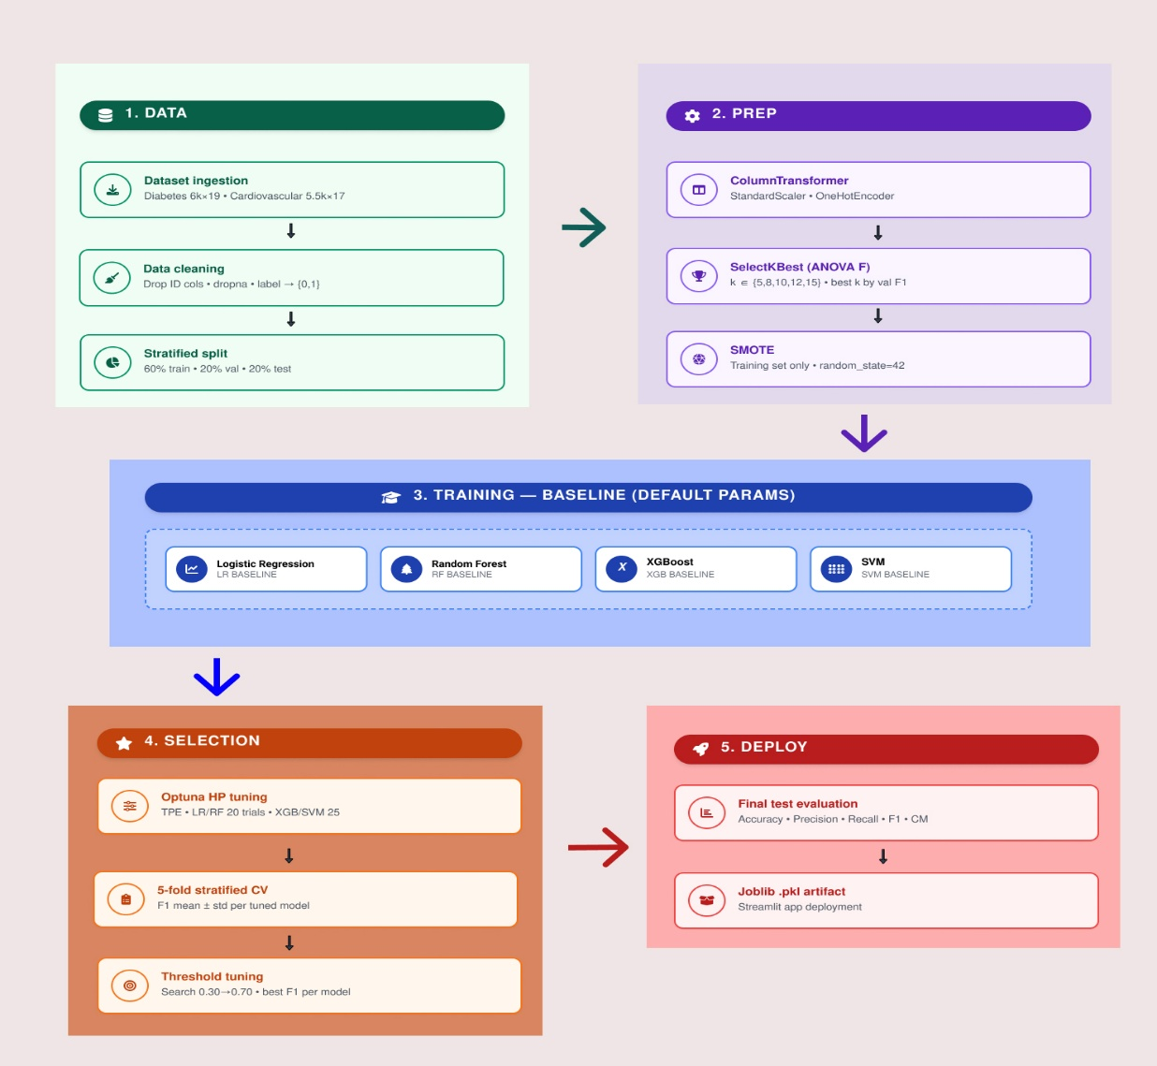
Fig 2: Complete methodology Workflow
- Dataset Collection: Two health care data sets were used in the current project one for predicting diabetes and the other for predicting cardiovascular disease. Patient information like the glucose concentration, body mass index, insulin concentration and the blood pressure along with the number of sleeping hours, stress and family history data set was used for predicting diabetes. Whereas the cholesterol level, blood pressure, heart rate, smoker and nonsmoker status, physical activity and the diet quality score were included in the cardiovascular disease data set. The selection of these data sets was made keeping in mind their medical and lifestyle related factors.

- Data splitting: The sets were divided to train, validate and test them. That was necessary to evaluate the machine learning models. The way of dividing the data sets was a "stratified split", to maintain the distribution of the classes equally within all sets and not having too much variance. About 60% were used for training, 20% for validation and the final 20% are set aside to test. The training sets are used for actually training the machine learning models. Validation is mainly used for parameter selection, such as optimizing the threshold. The test sets are completely separated and are used only for final tests. This way, the models' reliability will improve and the overfitting probability will be decreased during training.

- Data Preprocessing: To a large extent, data preprocessing was done so that the datasets would be ready to go for machine learning models training. At this stage, special attention was paid to missing or invalid values as we did not want our model to generate any incorrect outputs during learning process. In relation to numerical features, variables like glucose level, cholesterol level, BMI, and blood pressure were scaled down by using standard scaler in order to have all variables on an equal footing. In terms of categorical variables including gender, smoking, physical activity, and family history, these were encoded to numerical values using OneHotEncoder. ColumnTransformer approach was utilized to combine both mentioned approaches of data preprocessing. The point here is that our model was trained using training dataset and then applied to validation and test datasets to prevent data leakage.
- Feature Selection: The feature selection process was done in order to separate those features that appear to be highly important in predicting diseases. Here, we applied the SelectKBest function along with the ANOVA F-statistic method. Different values of k were evaluated by fitting SelectKBest on the training data and measuring prediction performance on the validation dataset. The value of k producing the highest validation F1-score was selected.

For the diabetes dataset, k=12 turned out to be the top performer on validation, whereas for the cardiovascular dataset, k=15 was the best choice. Overall, doing feature selection reduced redundant data, speed up the training process, and increase the model accuracy. It also made the machine learning pipeline clean by keeping only the most informative features for prediction.

- Imbalance Handling (SMOTE): The datasets had class imbalance, where one class had more samples compared to other class. To tackle this issue, we used SMOTE (Synthetic Minority Oversampling Technique) on the training set. Basically, SMOTE generates synthetic instances for the minority class and it helps in equalizing the class distribution. This kind of balancing can improve the learning ability of the machine learning models, and prevents the model from learning too hard toward the majority class. SMOTE was applied only after preprocessing on the training datasets to avoid data leakage. After applying SMOTE, recall, F1-score, and the overall prediction quality for the disease risk prediction was improved.

- Model Training and Comparison: Baseline training refers to the process of training a model through its default settings, without undergoing any optimization or tuning during model training. In this project, baseline training was conducted in order to use the model results as the base or reference to compare the improved performance after optimizations are done. Several algorithms, such as Logistic Regression, Random Forest, XGBoost, and Support Vector Machine (SVM) were used to train the data set that was already pre-processed and filtered.

This phase was undertaken to find out how good or bad each algorithm would perform without doing any optimization. Metrics such as accuracy, precision, recall, and F1-score are measured in this process in order to use them as the benchmark for the optimized versions of each algorithm.

- Hyperparameter Optimization: Hyperparameter tuning is a crucial technique that seeks to optimize the effectiveness of the machine learning model. In this project Optuna was utilized to automatically identify the optimal set of hyperparameters for each prediction model. Hyperparameters define the parameters used when tuning a machine learning model including (but not limited to) number of trees, learning rate, max depth, and regularization parameter value.

Instead of trying to brute-force the tuning process, Optuna performed intelligent searches in order to determine the most optimal parameters. Many trials were run and the set of parameters were selected which yielded the best performance according to the metric chosen. This allowed the model to predict with the highest degree of accuracy and reliability possible.

- Cross-Validation: To ensure robust model performance, stratified 5-fold cross-validation was implemented in hyperparameter tuning and evaluation of the models. In this method, the training set was divided into five equal parts while retaining the same proportion of classes as that of the original set. During each round of cross-validation, four out of five parts were utilized for model training, while one part was used for model validation. This was performed five times in order to validate each part of the dataset as a separate one.

Finally, the averaged performance of all five rounds was taken into account to assess the quality of models. As compared to a single train-test split, this approach provides a more accurate measure of the model performance by decreasing the risk of overfitting. F1-score was chosen as an optimization criteria since this metric considers the balance between precision and recall, which is vital in real-world application in the field of healthcare.

- Decision Threshold Tuning: Threshold tuning was done so the prediction results could get better prediction performance than using the usual default probability i.e. 0.5. Instead of sticking to that, several threshold values, like 0.30 and 0.70 were tested using the validation dataset. For each threshold value, prediction performance was evaluated mainly using F1-score metric. The threshold value that produced the highest validation F1-score was selected as the final operational threshold for prediction.

For the diabetes prediction model, a threshold value of 0.6 produced the best validation performance, however the cardiovascular prediction model achieved the best result with a threshold value of 0.5. This process helped to reduce incorrect classifications and produce more balanced disease prediction results.

- Model serialization and Deployment: Once the model training and evaluation phase was done, the final selected machine learning models were saved with Joblib serialization, so later they can be deployed and used for future prediction. Each saved model artifact contains the trained model, preprocessing pipeline, feature selector and threshold value that is needed for prediction. Saving everything in the same package means that during deployment the exact same preprocessing, encoding, scaling, and feature selection steps used during training are also applied during deployment.

Deployment of the final model is done through the Streamlit framework, which allows building an interactive web interface for predicting the probability of having any of these diseases. The web interface contains two independent prediction components one for diabetes prediction and another for cardiovascular disease prediction. User inputs can be entered directly via the web interface.

- Tools Used:
In the process of designing AI-Based Early Disease Risk Prediction System, different software and technologies were employed in terms of handling data, training models, and designing interface respectively. The software chosen relied on its compatibility with machine learning algorithm, simplicity, and usability. The core programming language that was used was Python. This language is compatible with machine learning tasks, as well as supports data analysis. Several libraries of Python were employed in the process, namely:
- Pandas was used for handling and organizing datasets.
- Numpy handled mathematical operations and numerical computations.
- Scikit-learn was involved in preprocessing, feature selection, model training, and evaluation.
- Imbalanced-learn (imblearn) was used to apply the SMOTE technique for handling class imbalance
- XGBoost was used to implement the Extreme Gradient Boosting classifier for disease prediction.
- Optuna was used for automated hyperparameter optimization to improve model performance.
- Matplotlib and seaborn were used to visualize data and support analysis.
- Joblib was used for saving trained machine learning models.
- Streamlit was chosen to create the web-based interface where users can get predictions.

The project development process took place in VS Code which is an environment for coding. The datasets for diabetes and cardiovascular diseases were stored in CSV format. Tests were performed in the local environment in order to check the efficiency and prediction accuracy of the algorithm.

- Experimental Setup:
The proposed model's framework is constructed in an experiment setup aimed at developing machine learning models capable of predicting the risk of diseases in advance. In the entire process, it involves data acquisition, preprocessing, feature selection, model training, and producing the predictions.

Healthcare datasets used in this experiment include:
- Diabetes dataset
- Cardiovascular dataset

The datasets contained different attributes such as glucose level, blood pressure, cholesterol, body mass index, sleeping hours, physical activities, and stress level. The datasets underwent pre-processing to get rid of any inconsistencies in the form of missing values.

After the above, techniques for feature selection were applied to identify the attributes that are crucial in predicting disease. The attribute set obtained was used to train various models using machine learning algorithms. For each model, the dataset is divided into training, validating and test sets.

Afterward, the machine learning models were deployed into a Streamlit web application. The basic principle is for the user to input information on their health and lifestyle through the interface, after which the system will generate an output of the predicted disease level.

- Evaluation Metrics and Performance Measures:
The performance of the machine learning models was analyzed by means of commonly used binary classification metrics. Prediction results were divided into the categories of True Positive (TP), True Negative (TN), False Positive (FP), and False Negative (FN) values, thus providing an indicator of prediction accuracy for disease prediction.

Main criteria used in this study are as follows:
- Accuracy: Measures the overall correctness of the prediction model.

Accuracy = (TP + TN) / (TP + TN + FP + FN)

- Precision: Precision is the accuracy with which the model predicts positive disease cases:

Precision = TP / (TP + FP)

- Recall: Recall represents the proportion of the disease cases that were identified:

Recall = TP / (TP + FN)

  - F1-score: F1-score is a harmonic mean of precision and recall that reflects the balance between prediction, accuracy and reliability:

F1-Score = 2 × [(Precision × Recall) / (Precision + Recall)]

Confusion matrix is a tool to analyze the correct and incorrect prediction offering more clarity on the issues related to True Positive, True Negative, False Positive, and False Negative predictions. These techniques contributed to the higher reliability of the system and decreased number of errors in the predictions of diabetes and cardiovascular diseases.

CHAPTER 4: RESULTS

  - System Specification:
This Early Disease Risk Prediction System was designed and tested on a standard computer that is compatible to perform the machine learning tasks and the website hosting. Hardware specification was chosen to perform the models training, predictions and the interface well. Hardware and Software specification for the system developed in this project are as below:

Table 3: System specification
Component | Details
Operating System | Windows 11
RAM | 8 GB
Programming language | Python 3.10
Core libraries | Numpy, Scikit-learn, XGBoost, Pandas, Seaborn, Matplotlib
Model Storage | Joblib (.pkl files)
Framework | Streamlit
IDE | VS Code

  - Parameters and Configuration Settings:
The performance of the disease prediction system depends on different parameters and configuration settings used during preprocessing and model training. Proper parameter selection helped improve prediction, accuracy and model stability.

Both the diabetes and cardiovascular disease model followed the same setup. The dataset was divided into three parts: 60% designed for training, 20% reserved for validation and 20% allocated for the final testing. Feature selection was done using SelectKBest with the f_classif scoring method. The best number of features (K) was selected by testing K values of 5,8,10,12 and 15 and chose the one that gave highest F1 score on the validation set. SMOTE was applied only on training data to balance the classes before training. Four types of machine learning algorithms such as logistic regression, random forest, XGBoost, and support vector machines (SVM) were selected as benchmarking models. Their hyperparameters were automatically optimized using Optuna to improve predictive performance. Decision threshold tuning was also done on the validation set, verifying threshold from 0.30 to 0.70 in steps of 0.05.

Table 4: Model Configuration Parameters
Parameter | Value
Train / Validation / Test Split | 60% / 20% / 20%
Random State | 42
Class Balancing | SMOTE (training set only)
Feature Selection | SelectKBest (f_classif)
K value tested | 5,8,10,12,15
Threshold Range | 0.30 to 0.70 (step=0.05)
Cross validation | 5-Fold (F1-scoring)
LR Max Iteration | 1000
Optuna Sampler | TPE

  - Experimental Results and Observations:
This part provides the comprehensive experimental results acquired from each disease dataset. It showed that the proposed AI-based system can predict disease risk effectively using patient health and life style. Different machine Learning models were tested during the development process. Hyperparameter optimization was performed using Optuna with 5-fold stratified cross validation on the training set. The models were then compared using validation-set performance metrics, followed by decision threshold tuning, followed by best model selection, and final test evaluation. The best performing models were selected for deployment in the web application.

    - Diabetes Disease Prediction:
The diabetes dataset was processed and split into training, validation, and testing sets. Four classifiers were trained and evaluated using the pipeline described in the chapter 3 section 3.3.

Table 5: Diabetes Baseline Model Comparison on Validation Dataset
Model | Accuracy | Precision | Recall | F1 Score
SVM | 0.9525 | 0.9698 | 0.9455 | 0.9575
Random Forest | 0.9475 | 0.9583 | 0.9485 | 0.9534
Logistic Regression | 0.9766 | 0.9556 | 0.9500 | 0.9528
XGBoost | 0.9416 | 0.9538 | 0.9426 | 0.9482

Observation: SVM achieved the highest validation F1-score (0.9575), followed by Random Forest (0.9534). XGBoost produced the lowest validation performance among the baseline models.

Table 6: Diabetes K-Fold Cross-Validation F1 Scores
Model | Cross Validation F1 Score
Logistic Regression | 0.9544 +/- 0.0075
Random Forest | 0.9537 +/- 0.0053
XGBoost | 0.9524 +/- 0.0069
SVM | 0.9545 +/- 0.0061

Observation: SVM achieved the highest average cross-validation F1-score (0.9545), indicating strong and stable performance across folds. All models showed low standard deviation values, suggesting consistent results.

Table 7: Diabetes Optimized Model Comparison (Validation)
Model | Accuracy | Precision | Recall | F1 Score
Logistic Regression | 0.9491 | 0.9612 | 0.9485 | 0.9787
SVM | 0.9475 | 0.9611 | 0.9455 | 0.9532
XGBoost | 0.9458 | 0.9582 | 0.9455 | 0.9518
Random Forest | 0.9450 | 0.9568 | 0.9455 | 0.9511

Observation: After hyperparameter optimization, Logistic Regression achieved the top-performing model with an F1-score of 0.9787. SVM and XGBoost also showed competitive performance, while Random Forest achieved the lowest F1-score.

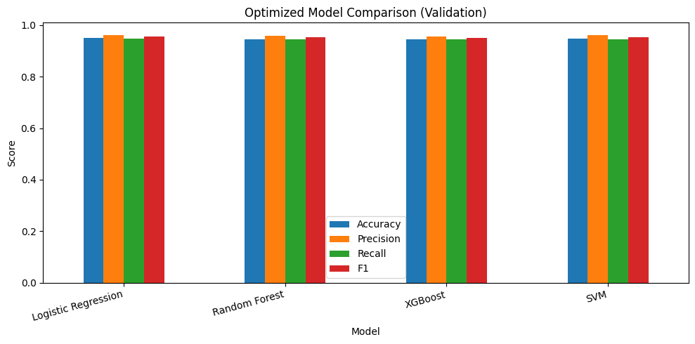

Fig 3: Diabetes Model Comparison Graph

Table 8: Diabetes Threshold Tuning
Model | Best Threshold | F1 Score
Logistic Regression | 0.5 | 0.9548
Random Forest | 0.55 | 0.9545
XGBoost | 0.55 | 0.9546
SVM | 0.6 | 0.9565

Observation: Various threshold values were tried to enhance the predictive performance. The accuracy of support vector machine was highest when the threshold value was 0.6. This adjustment helped to optimize the prediction of diabetes.

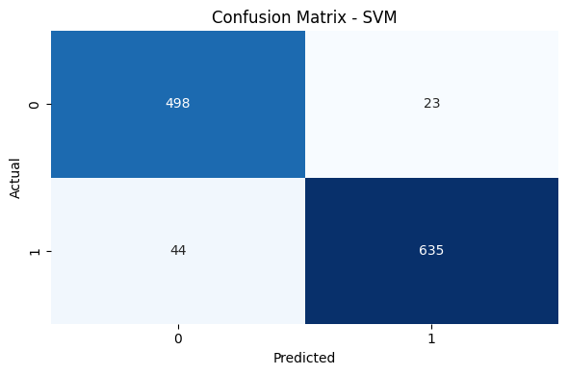
Fig 4: Diabetes Confusion Matrix

Observation: The SVM classifier was able to accurately predict most of the diabetes patients in the testing data set. It was able to provide a high number of correct positive and correct negative predictions with minimal errors.

    - Cardiovascular Disease Prediction:
The cardiovascular dataset was processed following the same pipeline as the diabetes dataset. All five classifier were trained and evaluated under identical experimental conditions.

Table 9: Cardiovascular Baseline Model Comparison on Validation Dataset
Model | Accuracy | Precision | Recall | F1 Score
Logistic Regression | 0.9709 | 0.9821 | 0.9740 | 0.9780
SVM | 0.9600 | 0.9804 | 0.9590 | 0.9696
XGBoost | 0.9518 | 0.9657 | 0.9618 | 0.9637
Random Forest | 0.9400 | 0.9512 | 0.9590 | 0.9551

Observation: Logistic Regression achieved the highest validation F1-score (0.9781), followed by SVM (0.9697). Random Forest produced the lowest validation performance among the baseline models.

Table 10: Cardiovascular K-Fold Cross-Validation F1 Scores
Model | Cross Validation F1 Score
Logistic Regression | 0.9696 +/- 0.0048
Random Forest | 0.9646 +/- 0.0049
XGBoost | 0.9699 +/- 0.0058
SVM | 0.9750 +/- 0.0054

Observation: SVM achieved the highest average cross-validation F1-score (0.9750), indicating robust and consistent performance across folds. All models showed low standard deviation values, suggesting consistent results.

Table 11: Cardiovascular Optimized Model Comparison (Validation)
Model | Accuracy | Precision | Recall | F1 Score
Logistic Regression | 0.9718 | 0.9821 | 0.9754 | 0.9787
SVM | 0.9600 | 0.9687 | 0.9713 | 0.9700
XGBoost | 0.9572 | 0.9660 | 0.9699 | 0.9680
Random Forest | 0.9390 | 0.9487 | 0.9604 | 0.9545

Observation: After hyperparameter optimization, Logistic Regression remained the top-performing model featuring an F1-score of 0.9787. SVM and XGBoost also showed competitive performance, while Random Forest achieved the lowest F1-score.

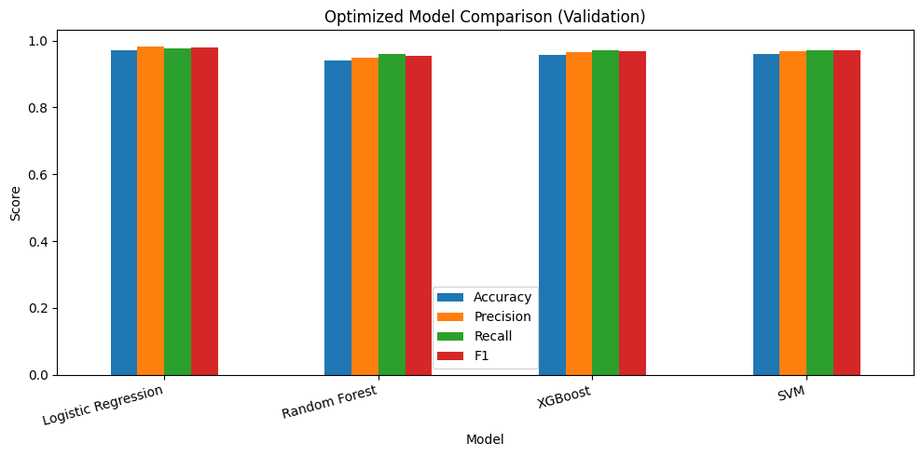
Fig 5: Cardiovascular Model Comparison Graph

Table 12: Cardiovascular Threshold Tuning
Model | Best Threshold | F1 Score
Logistic Regression | 0.5 | 0.9788
Random Forest | 0.55 | 0.9561
SVM | 0.55 | 0.9685
XGBoost | 0.5 | 0.9687

Observation: Threshold tuning was performed to improve prediction quality for each model. Logistic Regression achieved the best performance at a default threshold value of 0.50 gibing highest F1 score (0.9788).

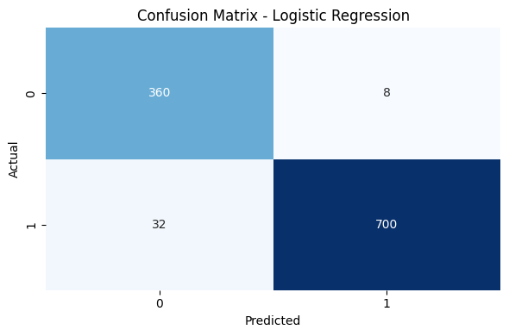
Fig 6: Cardiovascular Confusion matrix

  - Performance Analysis and Latency Bottlenecks:
Performance analysis: Performance testing was done for the evaluation of the efficiency of the proposed AI driven disease prediction model. It was done several times with various types of input values for the diabetic disease prediction side as well as for the cardiovascular disease prediction. In all tests, the proposed model provided prediction result with very high speed and also maintained stability without experiencing any issues during execution.

The web application built using Streamlit framework ran very smoothly and gave consistent prediction outputs. It was able to save time by not performing any repeated training of models, as models were saved and loaded with Joblib library and hence avoided repetition of the same process.

Latency Bottlenecks: The system slowdowns were observed, but mostly at the very beginning, during the first startup. That kind of delay happened mostly because the machine learning models and the python libraries needed to load into memory before the actual prediction execution. Once that initial loading step finished, predictions became much quicker and felt more responsive, with less waiting.

Another performance bottleneck showed up when dataset size increased during the model training phase. With larger datasets the model seemed to learn more, and improved prediction quality, but at the same time it increased training time and overall computational load. This delay was more noticeable during cross validation, model training and threshold tuning processes, because there the models were trained multiple times on different dataset combinations for performance evaluation.

  - Comparative Study and Discussion:

A comparative study was done to analyze the efficiency of various machine learning
models used for diabetes and cardiovascular diseases prediction. Various models were tested to determine which one gives more accuracy, stability, and balanced results.

Table 13: Final Test Performance Comparison (Diabetes vs. Cardiovascular disease)
Metric | Diabetes | Cardiovascular
Best Model | SVM | Logistic Regression
Optimal Threshold | 0.6 | 0.5
Test Accuracy | 0.9442 | 0.9636
Test Precision | 0.9650 | 0.9887
Test Recall | 0.9352 | 0.9563
Test F1 Score | 0.9499 | 0.9722
True Positives | 635 | 700
True Negatives | 498 | 360
False Positives | 23 | 8
False Negatives | 44 | 32

Above is the table showing the result comparison among best selected models for each disease. In case of diabetes, the best selected model is SVM, where it provided an accuracy of 94.42% and an F1 Score of 0.9499. In case of predicting cardiovascular disease, the best selected model is Logistic Regression, which provided an accuracy of 96.36% and an F1 Score of 0.9722.

As evident from above comparison, the selection of the optimal model is highly dependent on the datasets used. SVM gives more efficient results while predicting diabetes because of better handling of dataset characteristics. However, logistic regression model is better at predicting cardiovascular diseases because of high association between input and output classes.

Threshold tuning was also an essential aspect to improve the prediction results. However, in the case of the diabetes dataset, the threshold value used for improving balancing was increased to 0.6 compared to the default value of 0.50. This is an indication that the choice of threshold is essential for improving prediction quality.

Based on the experimental outcomes presented above, we can deduce that the proposed multi-disease prediction system can accurately predict disease risks. These trained models contributed to improving prediction accuracy and reliability in both datasets.

CHAPTER 5: CONCLUSION

- Summary of contributions:
An effective AI-based system to predict the risks of diabetes and cardiovascular diseases is created via machine learning algorithms. The key idea was to evaluate the risk factors of the development of diseases in the early stage by using patients' health state and lifestyle data for taking timely preventive measures.

Various machine learning algorithms were used and tested: Logistic Regression, Random Forest, XGBoost, and Support Vector Machine (SVM). Such phases of the approach include: data preparation, features selection via SelectKBest, class balancing by using SMOTE, hyperparameters tuning via Optuna library, 5-fold stratified cross-validation, and decision threshold optimization to achieve better results.

Experimental analysis has proved that the suggested approach has shown good results on the two data sets under consideration. Specifically, for the diabetes data set, it was found that the SVM classifier was the most efficient, whereas for the cardiovascular diseases data set, Logistic Regression proved to yield the best performance.

For the purpose of making predictions on the fly, an easy-to-use web application was built with the help of streamlit library. For preserving consistency in different environment settings throughout the training and deploying process, the trained model and feature selection processes have been pickled using the joblib library. The suggested approach can be efficiently applied for predicting disease risks and making decisions in the health care industry because of its robustness and reliability.

- Operational Limitations:
Although the developed system produced accurate and stable prediction results, some limitations still exist in the current implementation.
  - The system currently supports only diabetes and cardiovascular disease prediction.
  - Prediction accuracy depends heavily on dataset quality and user input values.
  - Larger datasets increase model training time and computational load.
  - The system is designed for prediction support only and cannot replace professional medical diagnosis.
  - The project uses limited datasets, which may affect real-world generalization for all patient groups.
  - Initial application startup may take slightly longer due to model and library loading.
Despite these limitations, the system provides useful prediction support and demonstrates the applied utilization of machine learning in medical field applications.
- Future Scope:

The existing system can be enhanced by incorporating additional healthcare features and advanced machine learning functionalities in the future:
Possible future improvements include:
- Adding prediction support for more chronic diseases such as kidney disease, liver disease, and cancer.
- Using larger and real time healthcare datasets to improve prediction accuracy.
- Integrating deep learning techniques like Artificial Neural network for advanced disease analysis.
- Implementing more powerful and advanced machine learning models such as LightGBM to improve prediction accuracy and overall system performance
- Developing a complete application both web application as well as mobile friendly version currently it is a simple web interface.
- Adding user authentication and patient history management features.
- Adding explainable AI features to help users understand prediction results.
- Improve system speed and reducing model training for larger dataset
CHAPTER 6: REFERENCES

- Almustafa, K.M. (2020) ‘Prediction of Heart Disease and Classifiers’ Sensitivity Analysis’, BMC Bioinformatics, Vol.21, Article 278.

- Deberneh, H.M. and Kim, I. (2021) ‘Prediction of Type 2 Diabetes Based on Machine Learning Algorithm’, International Journal of Environmental Research and Public Health, Vol.18, No.6, Article 3317.

- Rajendra, P. and Latifi, S. (2021) ‘Prediction of Diabetes Using Logistic Regression and Ensemble Techniques’, Computer Methods and Programs in Biomedicine Update, Vol.1, Article 100032.

- Poonia, R.C., Gupta, M.K., Abunadi, I., Albraikan, A.A., Al-Wesabi, F.N., Hamza, M.A. and Bhatnagar, T. (2022) ‘Intelligent Diagnostic Prediction and Classification Models for Detection of Kidney Disease’, Healthcare, Vol.10, No.2, Article 371.

- Ahmad, G.N., Shafiullah, Fatima, H., Abbas, M., Rahman, O., Imdadullah and Alqahtani, M.S. (2022) ‘Mixed Machine Learning Approach for Efficient Prediction of Human Heart Disease by Identifying the Numerical and Categorical Features’, Applied Sciences, Vol.12, No.15, Article 7449.

- Hassan, C.A.U., Iqbal, J., Irfan, R., Hussain, S., Algarni, A.D., Bukhari, S.S.H., Alturki, N. and Ullah, S.S. (2022) ‘Effectively Predicting the Presence of Coronary Heart Disease Using Machine Learning Classifiers’, Sensors, Vol.22, No.19, Article 7227.

- Islam, M.A., Majumder, M.Z.H. and Hussain, M.A. (2022) ‘Chronic Kidney Disease Prediction Based on Machine Learning Algorithms’, Sensors, Vol.22, Article 7227.

- Uddin, K.M.M., Ripa, R., Yeasmin, N., Biswas, N. and Dey, S.K. (2023) ‘Machine Learning-Based Approach to the Diagnosis of Cardiovascular Vascular Disease Using a Combined Dataset’, Intelligence-Based Medicine, Vol.7, Article 100100.

- Nguyen, L.P., Tung, D.D., Nguyen, D.T., Le, H.N., Tran, T.Q., Binh, T.V. and Pham, D.T.N. (2023) ‘The Utilization of Machine Learning Algorithms for Assisting Physicians in the Diagnosis of Diabetes’, Diagnostics, Vol.13, No.12, Article 2087.

- Alzboon, M.S., Alqaraleh, M. and Bader, A.F. (2025) ‘A Comparative Study of Machine Learning Techniques for Early Prediction of Diabetes’, arXiv Preprint.

CHAPTER 7: APPENDICES

Appendix 1: Feature Descriptions and Input Parameters
This appendix provides complete reference tables for both datasets used in the AI-Based Early Disease Risk Prediction System Using Machine Learning i.e. diabetes dataset and cardiovascular dataset. Each table covers the dataset overview, full feature dictionary, class distribution, and key preprocessing decision applied during model training.
- Diabetes Disease Dataset
Table 14: Diabetes Disease Dataset Overview
Attribute | Detail
File Name | diabetes.csv
Total Records | 6,000 patients
Total Features | 19 columns
Target Column | diabetes_risk_category (Low Risk / Prediabetes / High Risk)
Binary Label Used | Low Risk = 0, High Risk = 1

Table 15: Diabetes Prediction Feature Dictionary:
Feature Name | Type | Description | Range / values
Patient_ID | Numerical | Unique patient identifier | 1-6000
age | Numerical | Patient age | 20-84
gender | Categorical | Patient gender | Male / Female
bmi | Numerical | Body Mass Index | 16.0 – 50.0
blood_pressure | Numerical | Blood pressure level | 91 - 200
fasting_glucose_level | Numerical | Fasting blood glucose level | 60 - 281
insulin_level | Numerical | Insulin measurement | 2.0 -55.9
HbA1c_level | Numerical | Average blood sugar level | 4.1 - 11.0
cholesterol_level | Numerical | Cholesterol level | 139 - 309
triglycerides_level | Numerical | Triglycerides level | 50 - 383
physical_activity_level | Categorical | Daily physical activity category | Low /Moderate /High
daily_calorie_intake | Numerical | Calories consumed per day | 1200 -5249
sugar_intake_grams_per_day | Numerical | Sugar intake per day | 0 - 255
sleep_hours | Numerical | Average sleep duration | 4.0 – 10.0
stress_level | Numerical | Stress level score | 1 - 10
family_history_diabetes | Categorical | Family history of diabetes | Yes / No
waist_circumference_cm | Numerical | Waist size measurement | 60.0 – 150.0
diabetes_risk_score | Numerical | Numerical risk score | 0 - 100
diabetes_risk_category | Categorical | Target label | Low risk / High risk

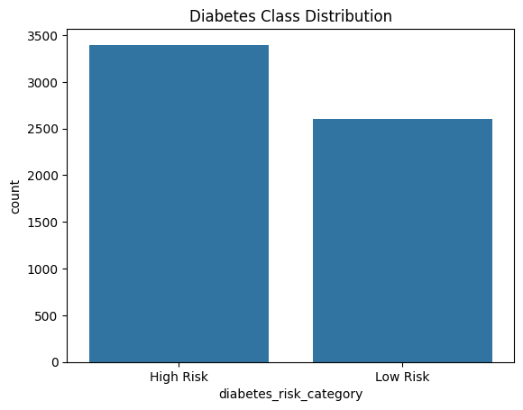

Fig 7: Diabetes class Distribution

Preprocessing Notes:
The subsequent preprocessing steps were performed before model training:
- Dropped Patient_ID and diabetes_risk_score before training
- Categorized Target label was encoded to binary labels where low risk was identifies as 0 and high risk was identified as 1 for facilitating model training and prediction purposes.
- Performed feature selection with select K best with an optimal number of k=12 and used the ANOVA f-statistics as a metric. Selected features include the following: BMI, blood pressure, fasting glucose levels, insulin level, HbA1C level, cholesterol levels, triglyceride levels, calorie intake per day, sugar intake per day, waist circumferences, physical activity level high and physical activity level low.
- Only the training split data was augmented using SMOTE while keeping the validation and testing set untouched.
- Numerical features were scaled using Standard scaler while Categorical features including gender, physical activity level and family history of diabetes were one hot encoded.

- Cardiovascular Disease Dataset
Table 16: Cardiovascular Disease Dataset Overview
Attribute | Detail
File Name | cardiovascular.csv
Total Records | 5,500 patients
Total Features | 17 columns
Target Column | risk_category (Low / Medium / High)
Binary Label Used | High = 1, Low = 0

Table 17: Cardiovascular Disease Prediction Features
Feature Name | Type | Description | Range/values
Patient_ID | Numerical | Unique patient identifier | 1 – 5,500
age | Numerical | Patient age | 18 - 90
bmi | Numerical | Body Mass Index | 15.0 – 40.9
systolic_bp | Numerical | Systolic blood pressure | 108 - 192
diastolic_bp | Numerical | Diastolic blood pressure | 64 - 120
cholesterol_mg_dl | Numerical | Cholesterol level | 147 - 331
resting_heart_rate | Numerical | Resting heart rate | 48 - 92
smoking_status | Categorical | Smoking habit | Never / Former / Current
daily_steps | Numerical | Number of daily steps | 500-16793
physical_activity_hours_per_week | Numerical | Exercise hours per week | 0.0 – 12.9
sleep_hours | Categorical | Sleep duration | 4.0 – 10.0
stress_level | Numerical | Stress score | 1 – 10
family_history_heart_disease | Categorical | Family history of heart disease | Yes / No
diet_quality_score | Numerical | Diet quality score | 1 – 10
alcohol_units_per_week | Numerical | Alcohol intake per week | 0.0 – 29.2
heart_disease_risk_score | Numerical | Numerical risk score | 0 – 100
risk_category | Categorical | Target label | Low / High

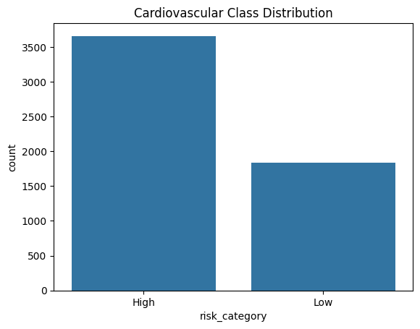

Fig 8: Cardiovascular class Distribution

Preprocessing Notes:
The preprocessing steps performed prior to the modeling process include:
- Removing patient ID number and heart disease risk score from the data because it does not add any value to prediction.
- Encoding the target labels in binary form, where the class of low is assigned to label 0, and class of high is assigned to label 1 for better modeling and prediction.
- For cardiovascular disease, the SelectKBest feature selection method identified 15 best features for validation, which included: age, body mass index, systolic blood pressure, diastolic blood pressure, cholesterol, resting heart rate, number of steps per day, stress level, exercise hours per week, dietary habit score, alcohol consumption per week, smoking status, Current, smoking status Never, family history of heart disease (No), and family history of heart disease (Yes).
- Over-sampling using SMOTE to balance the class distribution of the target variable in the train split only.
- Scaling numeric variables using StandardScaler and encoding categorical features using OneHotEncoder.
Appendix 2: Application Implementation and Prediction Workflow
This appendix Describes the implementation of the Streamlit based AI healthcare application developed for early diabetes and cardiovascular disease risk prediction. The appendix focuses on model integration, dynamic user interface generation, prediction workflow execution, validation mechanisms, and system-level implementation components used in the final application.
- Streamlit Application Structure: The application was developed using the Streamlit framework to provide an interactive healthcare prediction dashboard. The system contains separate modules for Home, Diabetes Prediction, Cardiovascular Prediction, and Model Information sections. Sidebar navigation was implemented to allow users to switch between disease prediction modules dynamically.
Code Snippet: Sidebar Navigation Implementation
selected_page = st. sidebar.radio(
"Go to",
[
"Home",
"Diabetes Prediction",
"Cardiovascular Prediction",
"Model Information",
],)
- Model Loading Pipeline: The system dynamically loads serialized machine learning model artifacts using Joblib. Each artifact contains the trained model, preprocessing pipeline, feature selector, selected feature list, and optimized decision threshold. This approach ensures that the prediction pipeline remains fully synchronized with the original training workflow.

Code Snippet: Model Loading Implementation
artifact = joblib.load(model_path)
bundle = {
"model": artifact.get("model"),
"preprocessor": artifact.get("preprocessor"),
"selector": artifact.get("selector"),
"features": artifact.get("features", []),
"threshold": artifact.get("threshold", 0.5),
}

- Prediction Execution Workflow: The prediction execution workflow follows the same sequence used during model training. User inputs are transformed using preprocessing operations, followed by feature selection and probability-based inference. Final predictions are generated using threshold comparison logic.

Code Snippet: Prediction Execution Pipeline
processed = preprocessor.transform(input_df[input_cols])
selected_data = selector.transform(processed)
probability = float(model.predict_proba(selected_data)[0][1])
prediction = 1 if probability >= threshold else 0

- Prediction Interface and Output Screens: The following screenshots illustrate the implemented graphical user interfaces and prediction outputs of the AI-based healthcare system. The application supports both diabetes and cardiovascular disease prediction modules and displays personalized prediction results with health recommendations for both low-risk and high-risk cases
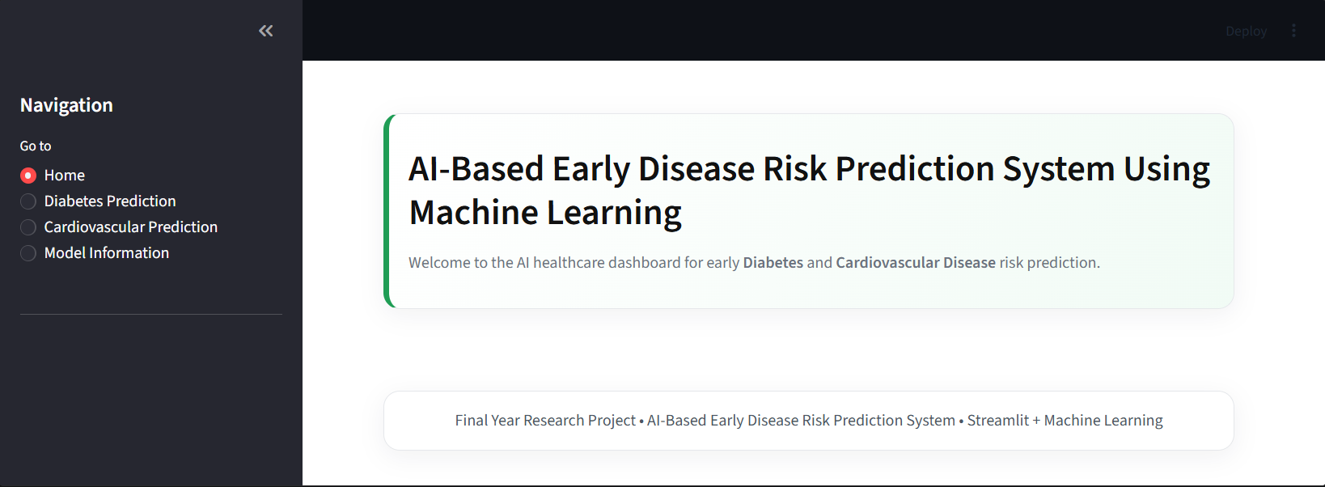

Fig 9: Home Page of the AI-Based Early Disease Risk Prediction System

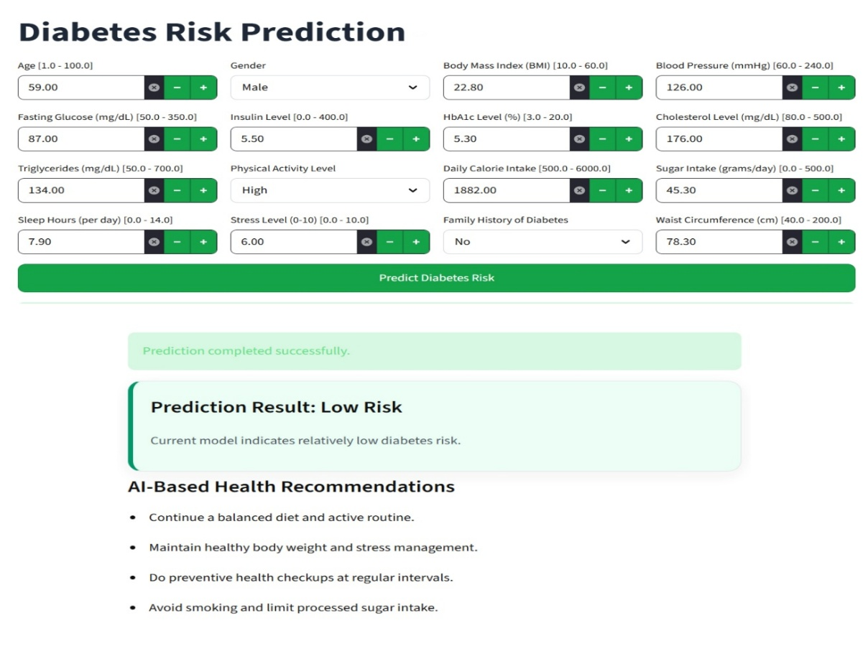
Fig 10: Diabetes Prediction Interface Showing
Low Risk Prediction

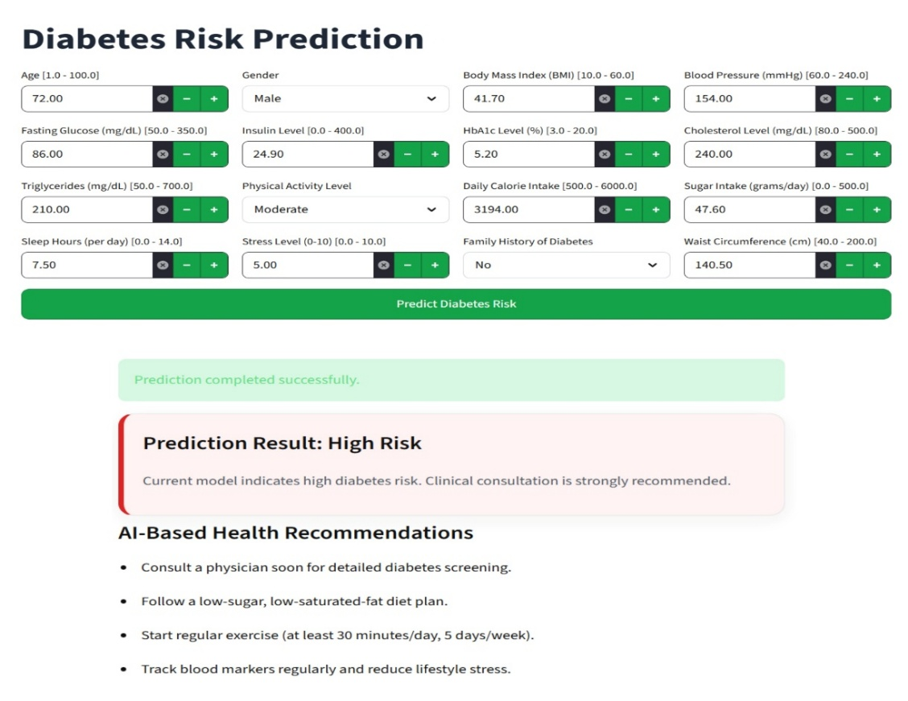
Fig 11: Diabetes Prediction Interface Showing
High Risk Prediction

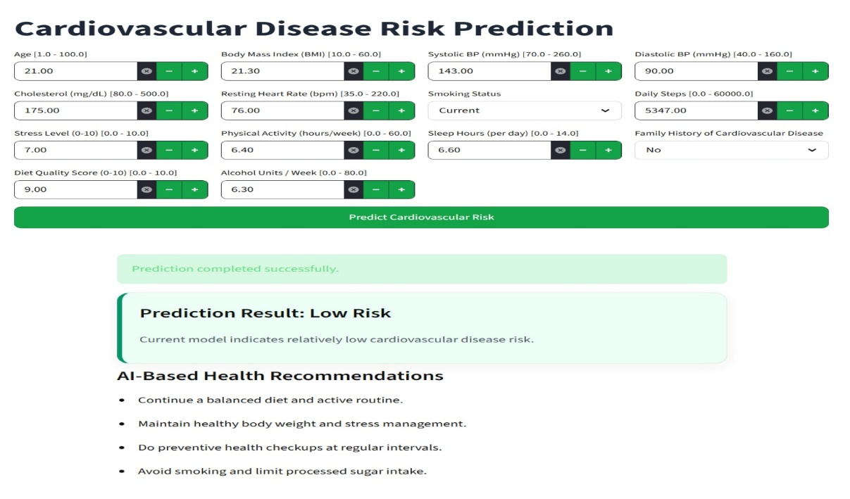
Fig 12: Cardiovascular Disease Prediction Interface Showing
Low Risk Prediction
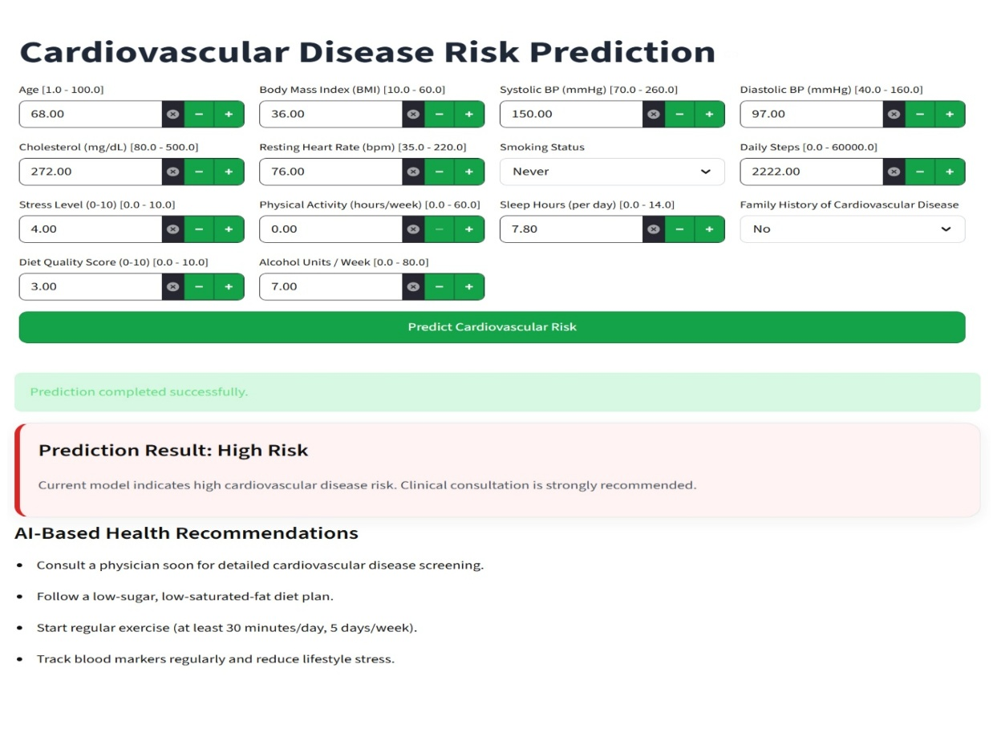

Fig 13: Cardiovascular Disease Prediction Interface Showing
High Risk Prediction

CHAPTER 8: REFLECTION OF THE TEAM MEMBERS ON THE PROJECT

Team Learnings: The development of the AI-Based Early Disease Risk Prediction System helped the team gain both technical and collaborative learning experience across the whole project lifecycle. In general, the team understood how machine learning can be applied in the healthcare space, to estimate disease risks using patient health parameters. During the project, the member learned the importance of data preprocessing, feature selection, model training, evaluation metrics, and how to interpret results properly, so the predictive system stays accurate. The team also experienced practical challenges when working with healthcare datasets such as data imbalance and maintaining prediction reliability.

Beside the technical side, the whole project sharpened teamwork communication and task management among all members. Everyone contributed in different areas like literature survey, dataset collection and experimentation, documentation and result validation, which helped in maintaining smooth project execution. Overall, the project provided valuable exposure to machine learning implementation, healthcare analytics, and software development which will be useful later for future academic and professional work.

Individual Learnings:
- Priyansu Nayak: This project provided me with a practical experience in machine-learning and healthcare analytics. I learned how to identify a problem in the real world and design a structured solution using AI techniques. Experimentation taught me more about data preparation, feature selection, model training, evaluation and prediction analysis. I also learned how to deploy machine learning models into an application using Streamlit for real-time prediction. Preparation of documentation improved my technical writing and reporting skills. This project helped me to develop my problem-solving skills, team spirit and self-confidence in managing the entire project development process from research to implementation and testing.

- Subhojeet Sarkar: This project taught me the importance of choosing proper datasets for machine learning systems. I looked at various health datasets and saw how data quality affects prediction accuracy and model performance. This increased my knowledge on dataset collection, comparison and selection techniques. I also worked on manuscript documentation which helped me to improve my technical writing and content organization skills. Overall, the project gave us valuable learnings in researching, documentation and health care data analysis.

- Himanshu Sekhar Dash: This project has helped me to have a better understanding of the applications of machine learning on healthcare systems. In the literature review I went through research papers and existing disease prediction methods, which improved my research and analytical skills. I learned how to define system requirements and help in problem formulation and solution design. This experience enhanced my knowledge of project planning and workflow management. I also learned how to communicate and present ideas better when talking to team members.

- Pikesh Yadav: Through this project, I got hands-on knowledge regarding UI Integration Testing in Machine Learning applications based on Streamlit. The project gave me an insight on how to represent prediction output in various ways through graphs, tables, etc. It also helped me in testing the output predictions and validating the disease prediction workflow to make sure that the system works effectively. The experience gained from this project increased my knowledge on ML evaluation and disease prediction systems.

CHAPTER 9: SIMILARITY REPORT

